SECTION A: Multiple-choice questions

Instructions for Section A
Answer all questions in pencil on the answer sheet provided for multiple choice questions.
Choose the response that is correct or that best answers the question.
A correct answer scores 1, an incorrect answer scores 0.
Marks will not be deducted for incorrect answers.
No marks will be given if more than one answer is completed for any question.

Use the following information for Questions 1 and 2
A fuel cell which uses methanol as the energy source has been developed by chemists. The simplified
diagram below shows its structure.

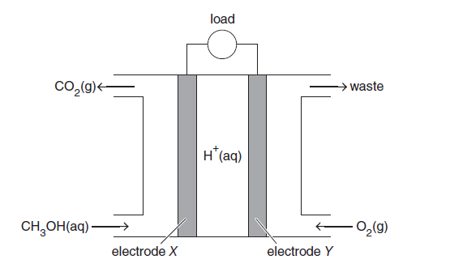

Question 1
The fuel cell is different to a secondary cell because in a fuel cell
A. | a spontaneous redox reaction is used.
B. | reactants are continuously replenished.
C. | the polarity of the electrodes is reversed.
D. | cations travel towards the cathode.

Question 2
Methanol can be produced from a number of sources.
Which one of the following sources is least sustainable?
A. | methane extracted from natural gas being converted to methanol in a two-step process
B. | decomposition of organic waste producing methane from which methanol is generated
C. | fermentation of carbohydrates producing a mixture of alkanols, including methanol
D. | modified bacteria using plant structural material in special digesters to produce methanol

Question 4
A galvanic cell is constructed from a chlorine half-cell connected to a manganese half-cell under standard laboratory conditions.
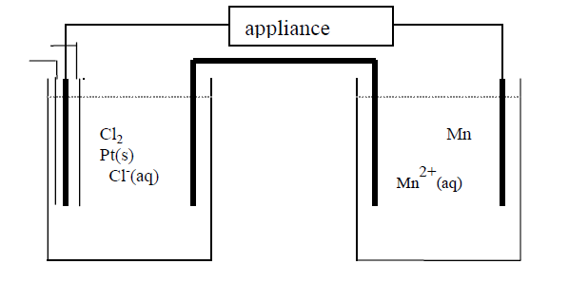
Cl⁻ (aq)
Mn²⁺ (aq)
Cl₂ (g)

Pt(s)
Mn(s)

In this cell
 | oxidant | Reductant | Negative Electrode | Positive Electrode
A. | Mn²⁺ | Cl— | Pt | Mn
B. | Mn | Cl₂ | Mn | Pt
C. | Cl₂ | Mn | Mn | Pt
D. | Cl— | Mn²⁺ | Mn | Pt

Question 5
A 100 g sample of a metal was heated to 100ºC and then quickly immersed in 200 g of water in an insulated container. The water was initially at 22.6ºC and when the water and the metal reached thermal equilibrium, the temperature had increased to 29.0ºC.

What was the specific heat capacity, in J g⁻¹ ºC⁻¹, of the metal?

A. | 0.376
B. | 0.754
C. | 3.26
D. | 4.18

Question 6
A food company is investigating using methane produced by bacterial decomposition of food waste to reduce the use of heating oil which has an average energy value of 38.5 MJ L⁻¹. What is the maximum volume of heating oil that would be saved if 2.45 $×$ 10⁵ L of methane, stored at SLC, is produced from food waste?

A. | 231 L.
B. | 431 L.
C. | 636 L.
D. | 2.56 $×$ 10³ L.

Question 9
Consider the following thermochemical equations:

Pb_{(s)} + CO_{(g)} PbO_{(s)} + C_{(s)} ΔH = -106.8 kJ mol⁻¹
2C_{(s)} + O_{2(g)} 2CO_{(g)} ΔH = -221.0 kJ mol⁻¹

The change in heat energy when 250 g of lead reacts with oxygen to form lead oxide is closest to:

A. | -262 kJ
B. | +262 kJ
C. | -435 kJ
D. | +435 kJ
Question 10
The E⁰ values for reduction reactions involving chromium are shown below.

Reduction reactions | E⁰ values
Cr₂O₇^{2—}_{(aq)} + 14H⁺_{(aq)} + 6e⁻ 2Cr³⁺_{(aq)} + 7 H₂O_{(l)} | 1.33 V
Cr³⁺_{(aq)} + e— Cr²⁺_{(aq)} | -0.41 V
Cr³⁺_{(aq)} + 3e— Cr_{(s)} | -0.76 V
Cr²⁺_{(aq)} + 2e— Cr_{(s)} | -0.91 V

Which of the following could be used to reduce chromium from an oxidation state of +6 to +3 only?

A. | Cu
B. | Al
C. | Mn
D. | Fe

Use the following information to answer Questions 11 and 12.

The chemical reaction represented below proceeds readily and rapidly in aqueous solution at room temperature.

Br_{2(aq)} + SO_{2(aq)} + 2H₂O_{(l)} 2Br–_{(aq)} + 4H⁺_{(aq)} + SO₄^{2–}_{(aq)}

It is proposed that a galvanic cell be constructed using this reaction, as shown below.
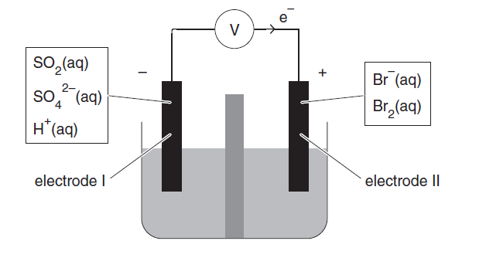
membranes

${Br}^{- }$(aq)
${Br}_{2}$ (aq)
$${SO}_{2}(aq)$$
${ SO}_{4}^{2-}$ (aq)
H⁺ (aq)

Question 11
When this cell is operating, electrode I will be the

A. | anode, at which SO₂ undergoes oxidation.
B. | anode, at which Br₂ undergoes oxidation.
C. | cathode, at which SO₂ undergoes reduction.
D. | cathode, at which Br₂ undergoes reduction.

Question 12
When the cell is operating, the pH of the solution close to electrode I would initially be expected to:

A. | increase.
B. | decrease.
C. | remain unchanged.
D. | fluctuate rapidly.

SECTION B

Instructions for Section B
Answer all questions in the spaces provided. Write using black or blue pen.
To obtain full marks for your responses you should
- give simplified answers with an appropriate number of significant figures to all numerical questions; unsimplified answers will not be given full marks.
- show all working in your answers to numerical questions. No marks will be given for an incorrect answer unless it is accompanied by details of the working.
- Make sure chemical equations are balanced and that the formulas for individual substances include an indication of state; for example, H_{2(g);} NaCl_{(s)}

Question 1 (5 marks)
In a problem-solving exercise, a student was provided with four half-cells under standard laboratory conditions. The aim was to place the half-reactions in the correct order in an electrochemical series. The half-cell reduction reactions, in random order, are shown in the table below.

Half-cells | Reduction half-equations
A | Cr²⁺_{(aq)} + 2e Cr_{(s)}
B | NO₃—_{(aq)} + 4H⁺_{(aq)} + 3e NO_{(g)} + 2H₂O_{(l)}
C | Au³⁺_{(aq)} + 3e Au_{(s)}
D | MnO₄—_{(aq)} + 3e MnO₄^{2—}_{(aq)}

In a series of experiments, two half-cells were connected at a time and experimental observations were made
as follows:
Half-cells | Reduction half-equations
A and B | Gas bubbles are produced at one electrode.
C and D | The gold electrode increases in mass.
B and C | The pH near one electrode decreases.

- i. Give the formula of an oxidant from the experiment which is known to be stronger
than acidified NO₃—_{(aq)}

ii. Give the formula of a reductant from the experiment which is known to be a stronger
reductant than NO(g).
1 + 1 = 2 marks

- Write the balanced equation for the cell reaction produced by connecting half cells A and B.
1 mark

c. The standard hydrogen half-cell was not used in the problem-solving exercise.
Explain how the standard hydrogen half-cell could have been used in this exercise to gain further information about the correct order of the half-reactions in the electrochemical series given in the data booklet.

2 marks

Question 2 (8 marks)
Continued increases in the price of oil has sharpened focus on alternative fuels for motor vehicles, particular biochemical fuels and hydrogen. Hydrogen can be produced from water and used in hydrogen internal combustion engines or fuel cells.
A hydrogen energy cycle for the use of hydrogen as a fuel is represented below.

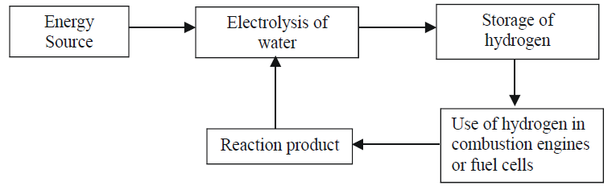

- Identify one concern currently associated with the production of biochemical fuels.
1 mark
b. i. What is the main environmental impact of the use of brown coal to generate electricity?

ii. Identify two sources of electricity which may be used for the electrolysis of water but do not have the environmental impact of brown coal.
1 + 1 = 2 marks

c. i. Write a thermochemical balanced equation for the complete combustion of hydrogen gas.

ii. Determine the heat of combustion of hydrogen gas in kJ g^{–1.}
2 + 1 = 3 marks

d. Hydrogen can be produced by the electrolysis of a dilute aqueous solution of potassium chloride. Write balanced half-equations for the reactions occurring at the (-) and (+) electrodes during this electrolysis.

(-) electrode: ________________________________________________________________________

(+) electrode: ________________________________________________________________________
2 marks

Question 3 (10 marks)
The molybdenum-air battery is typically lighter and provides more energy than an ordinary primary
battery because of the use of air, which is passed over the positive electrode. The battery is able to operate efficiently in either an acidic or alkaline electrolyte. The following half equations show the reduction of the molybdite ion (${MoO}_{4}^{2-}$) in different solutions.

H₂MoO_{4(aq)} + 6H⁺_{(aq)} + 6e⁻ Mo_{(s)} + 4H₂O_{(l)} E⁰ = -0.11 V

MoO₄ ²⁻_{(aq)} + 4H₂O_{(l)} + 6e⁻ Mo_{(s)} + 8OH⁻_{(aq)} E⁰ = -0.91 V

- i. Write the half-equation for the reaction at the cathode in an operating alkaline molybdenum-air battery.

- Write the overall equation for an operating alkaline molybdenum-air battery
- What would be the expected operating voltage, at standard conditions, of an alkaline molybdenum-air cell?

1 + 1 + 1 = 3 marks
- Why can batteries such as the molybdenum-air battery contain a much greater proportion, by mass, of reductant than conventional primary cells?
1 mark

c. In a zinc-air cell, the anode reaction is represented by the half-equation

Zn_{(s)} + 2OH⁻_{(aq)} Zn(OH)_{2(s)} + 2e-

The maximum operating cell voltage under standard laboratory conditions is 1.65 V.

- Calculate the maximum amount of electrical energy, in kJ, available from the consumption of
1.00 mol Zn in an alkaline Zn-air battery.

- Calculate the maximum amount of electrical energy, in kJ, available from the consumption of
1.00 mol of molybdenum in an alkaline molybdenum-air battery.

- Energy density is the energy available per gram of reductant. Use workings to show that the energy density of an alkaline Zn-air cell is less than the energy density of an alkaline molybdenum-air cell, even though the molybdenum-air cell has a lower molar mass and higher cell voltage.

1 + 1 + 2 = 4 marks

d. Lithium ion cells are secondary cells which are rechargeable. They have operating voltages up to 3.7 V. What are the two key requirements for correct recharging of a lithium ion cell?

2 marks

Question 5 (5 marks)

Hydrocarbons are a common fuel which vary in energy densities. This means the same mass of two different fuels could produce different amounts of energy.

- What mass of pure methanol would release the same amount of energy as 1.00 g of methane?
3 marks

b. i. What is the trend in the heats of combustion as the molecular mass of the hydrocarbons increase?

ii. How do the heats of combustion of hydrocarbons compare to those of the corresponding alcohol?

1 + 1 = 2 marks

SECTION A: Multiple-choice questions

Question 3

Which of the following statements is true for an exothermic reaction:

- the energy absorbed to break the bonds in the reactants is greater than the energy released during the formation of the bonds in the product
- the activation energy of the forward reaction is smaller than the activation energy of the reverse reaction
- the change in enthalpy is positive
- increasing the temperature will drive the reaction forwards

Question 12
The thermochemical equation for the complete combustion of methane, CH₄, is:
CH₄ (g) + 2O₂ (g) CO₂ (g) + 2H₂O (g) ΔH = -889 kJ/mol
Which of the following energy profile diagrams best represents the energy changes that take place during this reaction?

A.
-889 kJ/mol
C.
-889 kJ/mol
B.
-889 kJ/mol
D.
-889 kJ/mol

SECTION B
Question 1 (5 marks)
On the graph below draw a reaction energy profile diagram using the following data for the equilibrium system:
reactants ⇌ products ΔH = −220 kJ mol⁻¹
The chemical potential energy for the products is 140 kJ mol⁻¹, and the activation energy for the uncatalysed forward reaction is 180 kJ mol⁻¹.
Be sure to label:
- The axes
- The scale used on the vertical axis
- The reactants and products

- (3 marks)

- On the same diagram show the profile for the catalysed reaction where the activation energy for the forward reaction is 60 kJ mol⁻¹. Be sure to label this as the catalysed reaction.

____________________________________________________________________________________________________________________________________________________________________
(1 mark)
- Calculate the activation energy for the catalysed reverse reaction.

____________________________________________________________________________________________________________________________________________________________________ (1 mark)

SECTION A: Multiple-choice questions

Question 1
Which of the following chemical reactions represents a redox reaction?
- Ca(OH)₂ (aq) + CO₂ (g) → CaCO₃ (s) + H₂O (l)
- Cr₂O₇²⁻ (aq) + 2OH⁻ (aq) → 2CrO₄²⁻ (aq) + H₂O (l)
- Na₂CO₃ (aq) + HCl (aq) → CO₂ (g) + H₂O (l) + NaCl (aq)
- 3CuS (s) + 8HNO₃ (aq) → 3CuSO₄ (aq) + 8NO (g) + 4H₂O(l)

Question 2
In which of the following equations does Fe²⁺(aq) act as a reductant?
- 2Fe²⁺ (aq) + Cl₂ (g) → 2Fe³⁺ (aq) + 2Cl⁻ (aq)
- Fe²⁺ (aq) + S²⁻ (aq) → FeS (s)
- Fe²⁺ (aq) + 2OH⁻ (aq) → Fe(OH)₂ (s)
- Fe²⁺ (aq) + Ca (s) → Fe (s) + Ca²⁺ (aq)

Question 3
A solution of laundry bleach contains as its active ingredient sodium hypochlorite NaOCl at a concentration of 4.0% m/v. What would be the number of moles of NaOCl present in a 1.0 litre bottle of bleach?

- 0.054 mole
- 0.54 mole
- 1.86 mole
- 4.00 mole

Question 7
Which of the following contains the greatest number of mole of hydrogen atoms?
- 0.2 mole of aspirin molecules, C₉H₈O₄
- 34.2 g of table sugar, C₁₂H₂₂O₁₁
- 49.0 L hydrogen gas at SLC
- 10.0 L of a 0.15 M H₂SO₄ solution

Question 12
Hydrogen peroxide (H₂O₂) decomposes slowly on standing. A student wishes to determine the quality of a bottle of hydrogen peroxide solution bought from a local chemist. The student decomposes 10.0 mL sample of hydrogen peroxide using a MnO₂ catalyst according to the equation:
MnO₂
2H₂O₂(aq) 2H₂O(g) + O₂(g)

If the student collected 192mL of dry oxygen at 20.0ºC and 100.7kPa pressure, determine the actual concentration of the hydrogen peroxide solution in g/100mL (%m/v).

- 0.0540 g / 100 mL
- 0.540 g / 100mL
- 5.40 g / 100mL
- 50.4g / 100mL

